

**BACHELOR OF INFORMATION TECHNOLOGY (HONS)**

**BIT304**

**Final Year Project I**

**PROJECT PLAN**

**BeautéPanda: Android Application for Beauty Enthusiasts**

**PROJECT PERIOD: 28th September 2018 – 28th December 2018**

**Student Name: Ayu Chrisniyanti Student Id: E1500352**

**Student Name: Lovely Student Id: E1500367**

**Student Name: Student Id:**

**15 Jalan Sri Semantan 1, Off Jalan Semantan, Bukit Damansara, 50490 Kuala Lumpur, Malaysia.**

**Tel : 603-2716 2000, Fax : 603 - 2095 7100**

1. **PROJECT TITLE**

The title of our project is  title is BeautéPanda: Android Application for Beauty Enthusiasts. It is an an android application that serves as a place of commerce that connects customers with sellers who offer makeup, hairdo and nails services. This application has two types of user, which are customer and seller (salon or makeup artist). Through this application, a user can register as a customer and he/she will be able to find salons or makeup artists and read information about the services offered. The user can also find information about the latest beauty trends.

1. **PROJECT MEMBERS**

|  |  |  |
| --- | --- | --- |
| **No** | **Student ID** | **Name** |
| 1 | E1500352 | Ayu Chrisniyanti |
| 2 | E1500367 | Lovely |

1. **PROJECT KEY WORDS**

* Makeup Artist
* Salon
* Appointment
* Beauty Service Categories
* Seller
* Customer

1. **PROJECT BACKGROUND**

In this modern era, people want to look beautiful everyday especially for women. If we talk about beauty, it will always be related to makeup and hairdo. In recent years, the needs of beauty services are growing rapidly, because they have become as important as clothing for women. Due to these increasing needs, the services are not only offered by beauty salons, but also individuals that have skilled in makeup, hairdo and other beauty services. However, it is not easy to find these individuals, and it is hard for them to reach out to the targeted customer, since there is no platform that connect both of them.

The increasing popularity of beauty services also increases the number of individuals or businesses that offer these services. They are called makeup artist and beauty salons. However, there are so many of them which makes the customers confused to choose which makeup artist or salon that have good price, have better quality, etc. The other problem is that customer should find the information about makeup artists one by one in the internet or social media such an *Instagram*. This process of searching for the suitable individuals/place to get the services will spend much of the customers’ time.

Therefore, we would like to solve the problems mentioned above by developing a mobile application. This android – based application will be called BeautéPanda. This application will help customer to find and compare makeup artist and beauty salons easily. The customer can also contact the makeup artist directly through the ‘*inbox’* menu that will provided in the application, and make an appointment to deliver the service. From the seller’s (makeup artist and beauty salon) point of view, this application will facilitate them to promote his/her service.

1. **AIMS OF THE PROJECT**

The aim of this project is to create an android application called BeautéPanda, which serves as a market place where people who are self-employed as makeup artist can offer their services and make themselves known to the customer. This application is also for beauty salons that have already had physical building for their business, but want to reach more customers by offering their services through this application. We also want to help customer finding the perfect makeup/hairdo/nails for any occasion, contact the seller and make an appointment, all from one application. Other than that, this application is also intended to give users information about beauty – related news.

1. **OBJECTIVES OF THE PROJECT**

There are several objectives that we should set to develop BeautéPanda, which are:

* Facilitate user (as customer) to search for a makeup artist or salon that offer the service he/she needs
* Facilitate user (as sellers) to offer their service and reach the customer
* Assist customer and seller to chat each other to make an appointment and confirm the order
* Provide a reminder feature so that both users will not forget about an appointment
* Let administrator to manage content of the news section and help section

1. **DIRECT CUSTOMERS/BENEFICIARIES OF THE PROJECT**

This application will be used for both the customers and sellers, which are makeup artist and beauty salons. For the sellers, they can upload their photos of beauty services and add description to attract customers, which will benefit them because they can promote their business and will be known by the customer. They will also get income when customer ‘buy’ their services. For the customers, this application will help finding information about the sellers and making appointment easier. The customers that will be using this application are mainly teen and adult women. The beauty services offered can also be for children, but since they are still young, they will not directly use the application to get a service.

1. **OUTPUTS EXPECTED FROM THE PROJECT**

Details of works and tasks done by each team member:

1. Ayu Chrisniyanti

* Develop project background
* Develop project schedule
* Literature reviews
* Requirement gathering
* User interface design
* Develop use case
* Develop class and sequence diagram
* Develop and testing prototype
* Develop database design
* Develop software methodology
* Requirement analysis

1. Lovely

* Develop aims of project and project objectives
* Develop work item list
* Develop resource plan list
* Risk management
* Literature reviews
* Requirement gathering
* Develop use case
* Develop class and sequence diagram
* Develop and testing prototype
* Develop software methodology
* Functional & non-functional requirements
* Structural design

1. **ORGANISATIONS/INDUSTRIES INVOLVED IN THE PROJECT** 
   1. STIKOM Bali
   2. HELP University
   3. Local beauty salons and makeup artists that provide data and photos to be used as samples in our application
2. **SYSTEM DEVELOPMENT METHODOLOGY**

The methodology that we will use for our project is Agile Methodology. This method has four core values which we view to be suitable in developing a mobile application in this digital and ever – changing era. These values are: individuals and interactions over processes and tools, working software over comprehensive documentation, customer collaboration over contract negotiation and responding to change over following a plan (Cockburn, 2002).

The core of agile software development methods can be defined as the use of light-but-sufficient rules of project behavior and the use of human- and communication-oriented rules. The agile process is both light and sufficient. Lightness is a means of remaining maneuverable. Sufficiency is a matter of staying in the game (Cockburn, 2002).

We choose Agile Methodology because it is a continuous cycle of improvement. Moreover, it focuses on communication between developers and users, and let the users participate in developing the application. This is better than the traditional development methodology because developer and user relation is not limited on the contract paper. This allows changes or additions to the application to meet the needs of users. We can have better understanding of the user and create our application to be as close as possible to what the users need.

1. **RISK MANAGEMENT PLAN**

|  |  |  |  |  |
| --- | --- | --- | --- | --- |
| # | Description | Probability % | Impact  1= low  5 = high | Mitigation Strategy |
| 1 | Lacking the skills and knowledge to develop a wholesome android application | 40 | 5 | Find online sources to learn how to properly develop android application and find an expert to consult or to give guidance |
| 2 | The application produced will have many bugs | 40 | 5 | Run unit and integration testing to the codes to find bugs, and run system testing when the application prototype has been created |
| 3 | Project is not finished within project period | 20 | 5 | Regularly hold meetings between project members so that the project is not neglected |
| 4 | Not being able to produce proper UML diagram to show the workflow of the application | 30 | 4 | Revise previous lecture notes for creating UML diagram and consult with the project supervisor to give corrections to the diagram |
| 5 | Loss of data due to virus infection | 10 | 4 | Regularly make a backup for all the files related to the project |

1. **WORK ITEM LIST**

|  |  |  |  |
| --- | --- | --- | --- |
| **Name / Description** | **Priority** | **Assigned To** | **Effort estimated (days)** |
| **Initiating** |  |  |  |
| Initial Meeting with Supervisor | High | Niya and Lovely | 1 |
| Project Theme Identification | High | Niya and Lovely | 1 |
| Supervisor Consultation | High | Niya and Lovely | 1 |
| Project Theme Decision | High |  | 0 |
| **Planning** |  |  |  |
| Develop Project Background | High | Niya | 2 |
| Develop Project Aims and Objectives | High | Lovely | 2 |
| Develop Work Item List | Medium | Lovely | 1 |
| Develop Project Schedule | Medium | Niya | 1 |
| Select Software Methodology | Medium | Niya and Lovely | 1 |
| Develop Resource Plan | Medium | Lovely | 1 |
| Develop Risk Management Plan | High | Lovely | 1 |
| Submission of Project Plan and Project Management Plan | High |  | 0 |
| **Executing** |  |  |  |
| Gathering Requirements | High | Niya and Lovely | 4 |
| Develop Literature Review | High | Niya and Lovely | 5 |
| Literature Review Submission | High |  | 0 |
| Prepare for Interim Presentation | Medium | Niya and Lovely | 9 |
| Interim Presentation | High |  | 0 |
| Develop Requirement Analysis | High | Niya | 3 |
| Develop Functional & Non-Functional Requirement | High | Lovely | 4 |
| Develop Use Case Diagram | Medium | Niya and Lovely | 2 |
| Chapter 3 Submission | High |  | 0 |
| Develop Analysis Class Diagram | High | Niya and Lovely | 1 |
| Develop Sequence Diagram | High | Niya and Lovely | 1 |
| Database Design | Medium | Niya | 1 |
| Structural Design | Medium | Lovely | 1 |
| User Interface Design | High | Niya | 4 |
| **Construction** |  |  |  |
| Coding for Prototype | High | Niya and Lovely | 3 |
| Testing | High | Niya and Lovely | 1 |
| Chapter 4 Submission | High |  | 0 |
| **Closing** |  |  |  |
| Develop Progress Report | High | Niya and Lovely | 6 |
| Prepare Final Documentation | High | Niya and Lovely | 3 |
| Final Report Submission | High |  | 0 |
| Final Presentation Preparation | High | Niya and Lovely | 4 |
| Final Presentation | High |  | 0 |

1. **WORK PLAN**

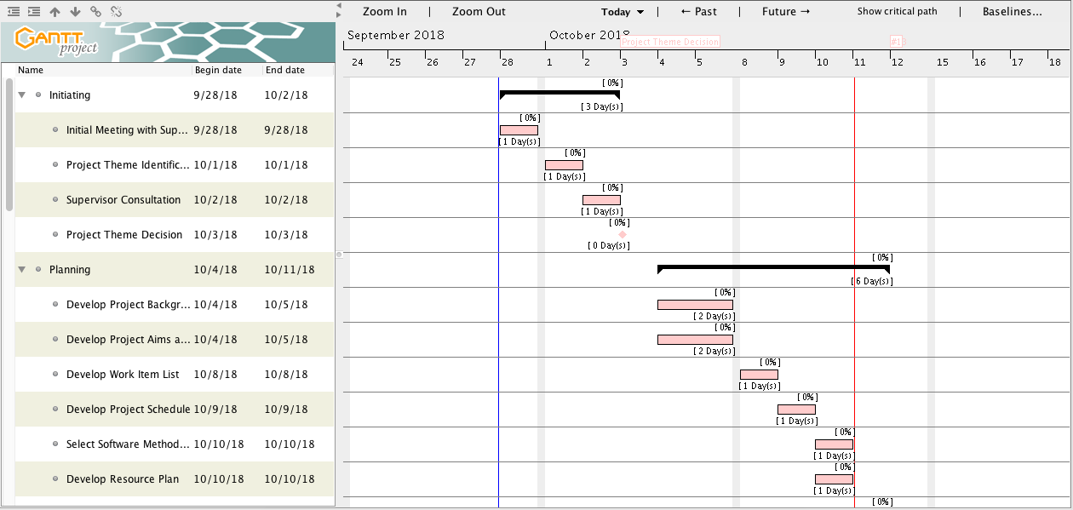

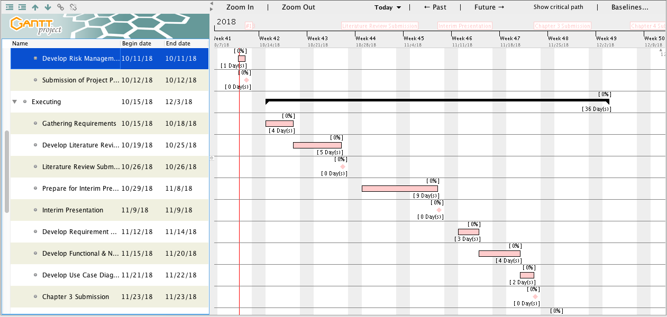

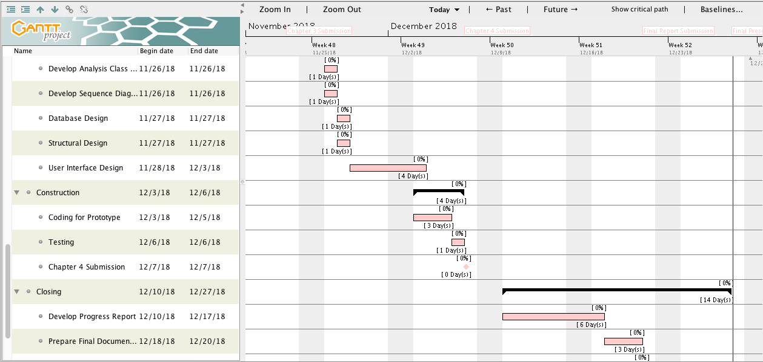

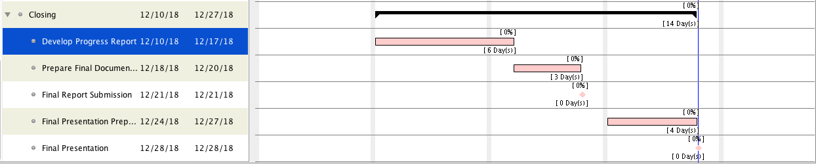

1. **DURATION**

Starting Date : 28th September 2018

Duration/elapsed time : 4 months

End Date : 28th December 2018

1. **PROJECT RESOURCE REQUIREMENTS AND ESTIMATED COSTS\***

|  |  |  |  |  |
| --- | --- | --- | --- | --- |
| **No** | **Item** | **Usage** | **Qty.** | **Cost** |
| Hardware | | | | |
| 1 | ASUS laptop X450J series | Project development | 1 | Available |
| 2 | Apple MacBook Pro Mid 2012 | Project development | 1 | Available |
| 3 | Samsung Galaxy A5 | Project testing | 1 | Available |
| 4 | Epson L210 printer | Document printing | 1 | Available |
| Operating system | | | | |
| 5 | Windows 10 | Project development | - | Available |
| 6 | MacOS Sierra 10.12.3 | Project development | - | Available |
| 7 | Android Nougat 7.0 | Project testing | - | Available |
| Others | | | | |
| 8 | IntelliJ IDEA Community Edition 2018.2.4 | Android application development | - | Available |
| 9 | Adobe Photoshop CS6 | User interface design | - | Available |
| 10 | Microsoft Visio Pro 2013 | Drawing UML diagrams | - | Available |
| 11 | GanttProject 2.8.5 | Creating project schedule | - | Available |
| 12 | Microsoft Office Word 2013 | Creating project document | - | Available |
| 13 | Microsoft Office PowerPoint 2013 | Creating presentation for the project | - | Available |
| **Estimated Project Cost** | | | | Rupiah 0,- |

1. **CONTRACTUAL OBLIGATIONS UNDER THIS PROJECT**

**Team Members**

Ayu Chrisniyanti : E1500352

Lovely : E1500367

1. **Code of Conduct**

As a project team, we will:

Work together to solve all problems encountered during the project

Develop a good relation with each other to support our teamwork so that we will finish on the due date

Distribute tasks and work items equally

Consider each other’s approach in developing the project

1. **Participation**

As a project team, we will:

* + - 1. Present in every meeting
      2. Responsible to do and finished the given tasks
      3. Help to solve problems in developing the project by giving solutions
      4. Open to any advice and suggestion to make the project better

1. **Communication**

As a project team, we will:

Clearly discuss the project goals and ideas

Communicate problems with each other and come up with the solution

Value each other’s view and opinion in developing the project

1. **Problem Solving**

As a project team, we will:

* + - 1. Communicate the problems in the project
      2. Give advice and suggestion to solve the problems
      3. Respect each other’s solution to solve the problems
      4. Provide a strategy to deal with problems that may have great impact to our project

1. **Meeting Guidelines**

As a project team, we will:

Decide on the project idea and distribute the tasks equally

Record the outcomes of every meeting

Use the necessary tools to finish the project

Evaluate the project result with the initial goal

1. **OWNERSHIP OF INTELLECTUAL PROPERTY RIGHTS**

All ownership and intellectual property belongs to HELP University

**PROJECT MEMBERS DECLARATION**

We hereby acknowledge that the all the information given above is true and correct to the best of our knowledge.

**Name :** Ayu Chrisniyanti

**Signature :**

**Date :**

**Name :** Lovely

**Signature :**

**Date :**

# **References**

Cockburn, A. (2002). *Agile Software Development.* Boston: Addison-Wesley.